North Dakota Society of Health-System Pharmacists
2020 Fall Health-System Summit and Expo

NDSHP is holding an Expo program in order to bring North Dakota’s Pharmacy Directors, Managers, and Administrators together to network with exhibitor representatives.
When: Thursday, October 22, 2020 8:00am—12:00pm
Where: Radisson Hotel, Fargo, ND
For more information on the Expo and how to register as an exhibitor, please visit www.ndshp.org or contact NDSHP at outreach@ndshp.org

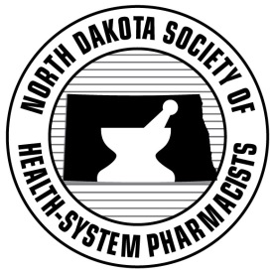

North Dakota Society of Health-System Pharmacists
2020 Fall Health-System Summit and Expo

NDSHP is holding an Expo program in order to bring North Dakota’s Pharmacy Directors, Managers, and Administrators together to network with exhibitor representatives.
When: Thursday, October 22, 2020 8:00am—12:00pm
Where: Radisson Hotel, Fargo, ND
For more information on the Expo and how to register as an exhibitor, please visit www.ndshp.org or contact NDSHP at outreach@ndshp.org

